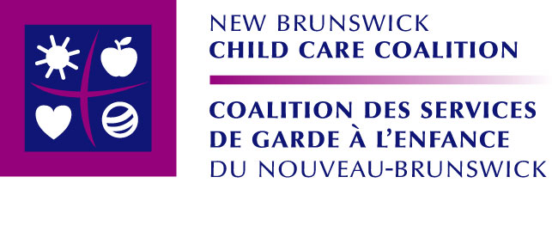
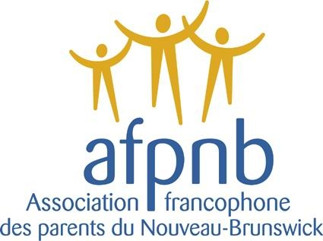

Press Release
For immediate publication

Early Learning and Childcare Act: Two organisations recommend modifications

April 7, 2010 – As the second reading of the Early Learning and Childcare Act approaches at the Legislative Assembly, the New Brunswick Child Care Coalition and the Association francophone des parents du Nouveau-Brunswick recommend the government bring important modifications before its adoption.

« We need to move away from a model where the government funds parents and work towards a model where funds flow directly to child care early childhood education programs. This way of doing things is recognised by the Organisation for Economic Co-operation and Development (OECD). It provides greater program stability and the government has better control on planning, on the size and location of the establishments, on the quality levels, as well as on the data evaluation and collection », explains New Brunswick Child Care Coalition executive director, Jody Dallaire.

To achieve this the Legislative Assembly must modify bill 49, the Early Learning and Childcare Act, to give the provincial government the power to change how it finances childcare services. The bill should also clearly state that funding be allocated specifically to early learning and childcare programs rather than to facility operators. It should also dictate the criteria for their allocation.

Although it includes positive elements for New Brunswick children, Bill 49 has to ensure that the early learning and child care system be based on research and best practices. The application of the New Brunswick Child Care Coalition and the Association francophone des parents du Nouveau-Brunswick’s recommendations would allow the government to reach this, which is one of the objectives it included in its Early Childhood Strategy.

« As most of families need childcare services, it is essential those be high quality, accessible services for all, regardless of their income. To reach those objectives, we have to make sure that the law follows the best practices in the field », says Association francophone des parents du Nouveau-Brunswick’s chairperson, Madeleine Vachon.

New Brunswick’s current approach to childcare, which relies on parent fee subsidies and educator wage subsidies, leaves the door open for a situation similar to Australia’s to occur. Australia’s model, like New Brunswick’s, forced little accountability for public expenses. It gave way to the implantation of what became the world’s largest child care corporation- traded on the stock exchange (before its collapse)- undermined quality, extraordinary rise in cost, the gross waste of taxpayers dollars and a public policy disaster. This is particularly important given that a big box childcare company is currently trying to get listed on the Toronto Stock Exchange to raise capital to expand across the Canada.

« The Early Learning and Childcare Act should give the government the power to keep big box child care companies out of New Brunswick and foster public and not for profit daycares. The private day cares that already exist could keep operating but, criteria for the allocation of funds based on principles of quality, inclusion, accessibility, public financing, community delivery and responsibility are also a part of our recommendations », says Dallaire.

The New Brunswick Child Care Coalition and the Association francophone des parents du Nouveau-Brunswick ask that Bill 49 confer, in en specific terms, the provincial government the authority to regulate funding allocated to services that respond to the needs of children with disabilities. These terms should ensure that the government goes towards covering the costs of teaching assistants, specialized equipment, transportation, adaptive technology and materials. To ensure inclusion, additional funding must be allocated directly to early learning and childcare programs to accommodate these children.

The New Brunswick Child Care Coalition and Association francophone des parents du Nouveau-Brunswick’s recommendations are evidence-based and promote public accountability in building a child care system.

Bill 49 will be debated in the Legislative Assembly on the occasion of its second reading.

-30-

Contacts

New Brunswick Child Care Coalition
Jody Dallaire
Executive director
(506) 855-8977
jody.dallaire@rogers.com

Association francophone des parents du Nouveau-Brunswick
Denyse LeBouthillier
Executive director
(506) 859-8107

